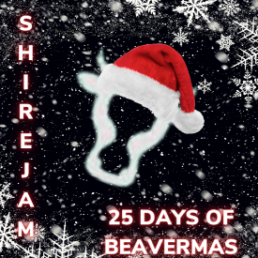
Handy Wreath

What Materials you will need for this acvitity

  - Green Card
  - Red Card
  - Scissors
  - Glue
  - Pencil
  - Ribbon

Approx how long will this take?
60 Minutes

How Hard is this (1 star Easy 3 hard)?

What Sort of Craft is this?
Create

Take it further

Make a hand print Christmas tree or reindeer
1
Using the green card, draw around your hand 20 times
2
With the red card, draw 12 circles, about 2 to 3cm big

3
with adult help, cut all of the handprints and circles

4
Lay the hand prints in a circle, ensuring they overlap, cirle needs to be roughly 30cm in diameter.

5
1 at a time gentle glue the hand prints on top of each other, trying to keep the shape of a circle

6.
Place your red circles in groups of 3 around your wreath and glue

7
Once dry, loop ribbon over wreath and tie a bow, then hang to show it off

Beavers

How To Do It

Top Skill Tips

1
Create

Saftey Tips

Adult help needed

