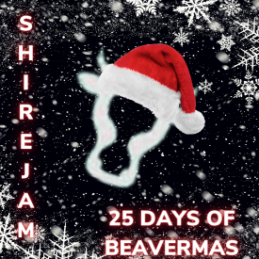
Winter Nature Walk

What Materials you will need for this acvitity

- Hat, Scarf, Gloves
- Coat
- Boots
- Family

Approx how long will this take?
60 minutes

How Hard is this (1 star Easy 3 hard)?

What Sort of Craft is this?
Activity

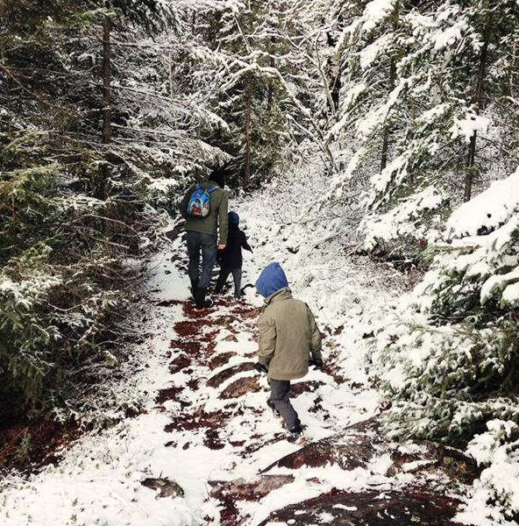

1
Get the family together
2
Wrap up warm in hats, scarf, gloves and coat, wear sensible footwear
3
Go on a nice winter nature walk and take lots of photos

4
Can you identify 5 different trees or plants?

Take it further

How about making an adventure Den

Beavers

How To Do It

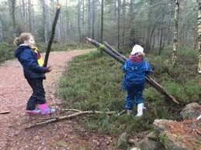

Top Skill Tips

1
Create

Saftey Tips

Adult help needed

